Assignment 10.5:

1. Write a pig script to find the top 20 destination people travel the most: Based on the given data

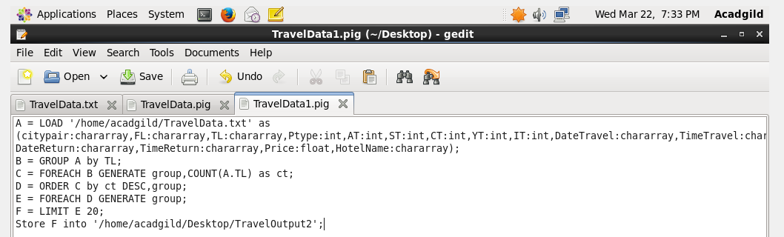

1. Group by To Location
2. Count the number of To Location in each group
3. Sort them in the descending order
4. Limit the output to first 20

Output:

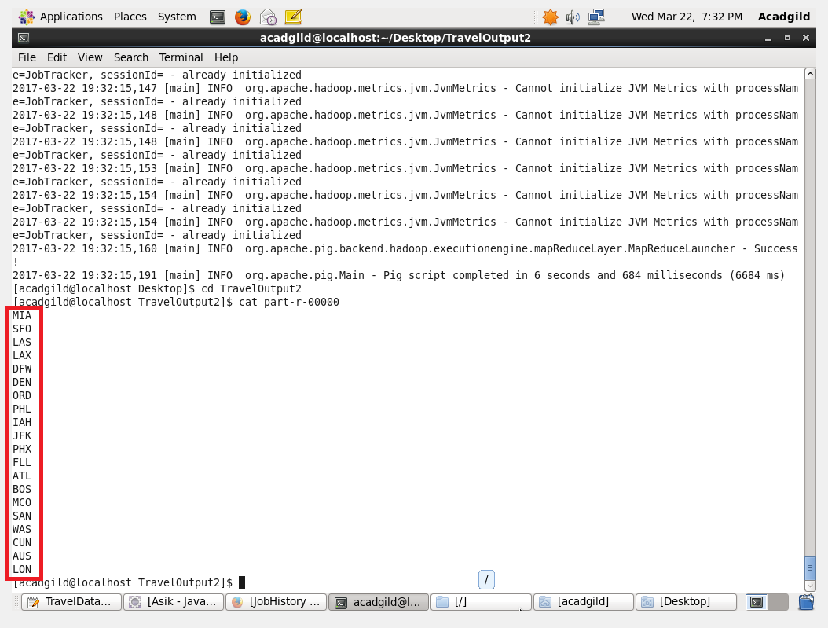

1. Write a pig script to find the top 20 locations from where people travel the most:

Pig Script:

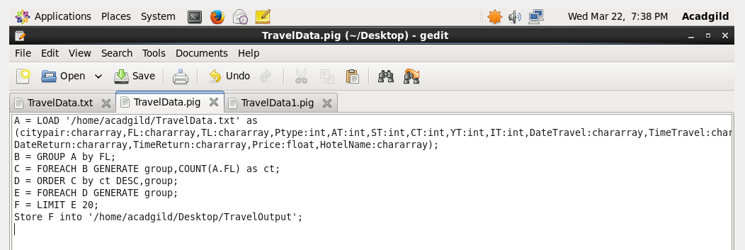

1. Group by From Location
2. Count the From Location in each group
3. Order in descending order.
4. Limit the output to top 20

Output:

